Microcontroller to Sensor

Interfacing with ADC

Overview:

Micro-controllers are useful to the extent that they communicate with other devices, such as sensors, motors, switches, keypads, displays, memory and even other micro-controllers. Many interface methods have been developed over the years to solve the complex problem of balancing circuit design criteria such as features, cost, size, weight, power consumption, reliability, availability, manufacturability. Many microcontroller designs typically mix multiple interfacing methods. In a very simplistic form, a microcontroller system can be viewed as a system that reads from (monitors) inputs, performs processing and writes to ( controls ) outputs.

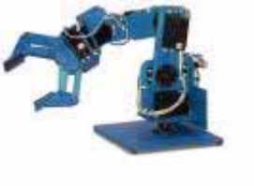
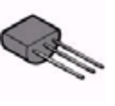
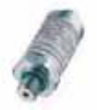
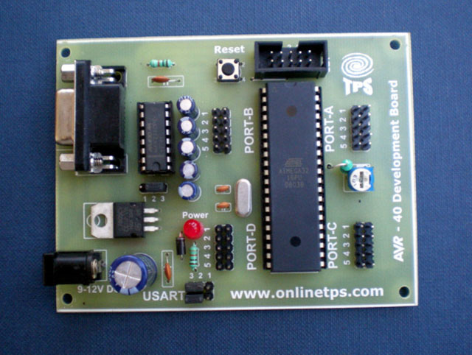

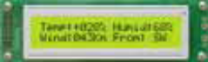
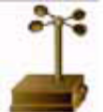
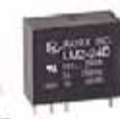
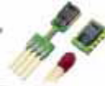

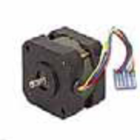
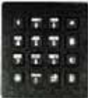

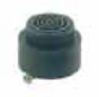
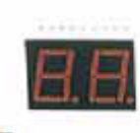
Voltage type: Typical ranges

- 0 to 2.5V
- 0 to 4V
- 0 to 5V
- +/- 2.5V
- +/- 4V
- +/- 5V
Current type: Typical ranges

- 0-20mA
- 4-20mA

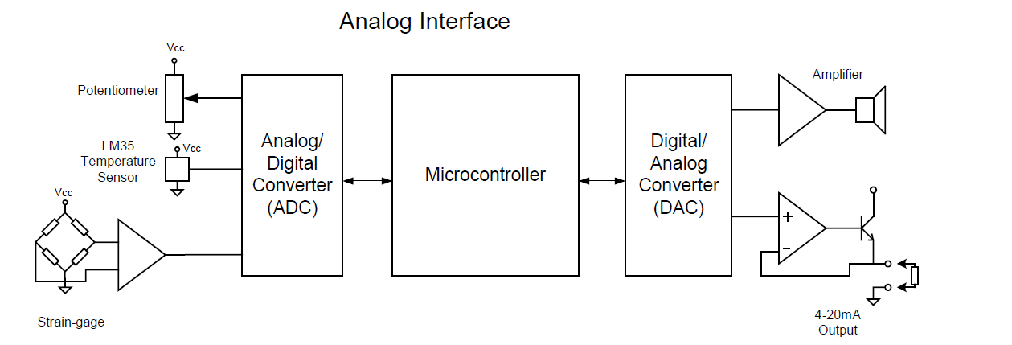
Sensor Types:

- Temperature
- Humidity
- Light
- Acceleration
- Force
- Frequency
- Flow
- Pressure
- Torque
- Proximity
- Displacement
Temperature Sensors:

- RTD
- Thermistor
- Thermocouple
- Semiconductor Temperature Sensors

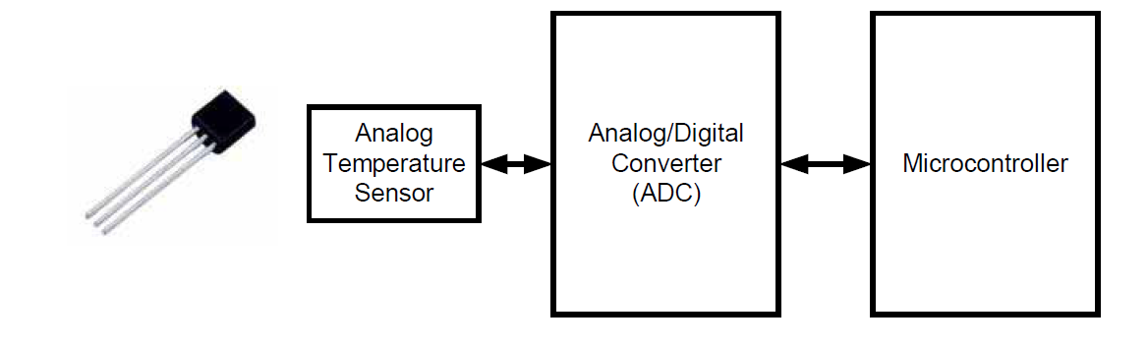

Many sensors, such as thermocouples, generate a relatively small voltage so noise is always an issue. The most common source of noise is the utility power lines (50 Hz or 60 Hz). Typically, the bandwidth for temperature sensors is much lower than 50 or 60 Hz so a simple low-pass filter will work well in many cases. Other measures to keep noise away:
• Keep the sensor wires short.
• Use shielded sensor cables with twisted pair wires.
• Use a dedicated precision voltage reference, not the microcontroller supply.
• Use 4-20mA loop or even better, a digital signal for long cable runs.
• Provide low impedance paths to ground at the ADC inputs if possible.
• Average readings in software.
• Analog ground and digital ground should connect at the ADC.
• Analog ground should not carry large currents.
• Ground planes should not carry any currents.

Analog-to-digital converters are among the most widely used devices for data acquisition. Digital computers use binary (discrete) values, but in the physical world everything is analog (continuous). Temperature, pressure, humidity, and velocity are a few examples of physical quantities that we deal with every day. A physical quantity is converted to electrical signals using a device called a transducer. Transducers are also referred to as sensors. Sensors for temperature, velocity, pressure, light, and many other natural quantities produce an output that is voltage. Therefore, we need analog-to-digital converter to translate the analog signals to digital numbers so that the microcontroller can read and process them.
An ADC has n-bit resolution where n can be 4, 8, 10, 12, 16 or even 24 bits. The higher resolution ADC provides a smaller step size, where step size is the smallest change that can be discerned by an ADC. In addition to resolution, conversion time is another major factor in judging an ADC. Conversion time is defined as the time it takes the ADC to convert the analog input to a digital number. The ADC chips are either parallel or serial.
The basic principle of analog-to-digital conversion is to use the comparator principle to determine whether or not to turn on a particular bit of the binary number output. It is typical for an ADC to use a digital-to-analog converter (DAC) to determine one of the inputs to the comparator. Following are the most used conversion methods:
- Digital-Ramp ADC
- Successive Approximation ADC
- Flash ADC
The above timing diagrams are from ADC0804 datasheet. The first diagram shows how to start a conversion. Also you can see which signals are to be asserted and at what time to start a conversion. So looking into the timing diagram FIGURE 1, we note down the steps or say the order in which signals are to be asserted to start a conversion of ADC. As we have decided to make Chip select pin as low so we need not to bother about the CS signal in the timing diagram. Below steps are for starting an ADC conversion. I am also including CS signal to give you a clear picture. While programming we will not use this signal.

- Make chip select (CS) signal low.
- Make write (WR) signal low.
- Make chip select (CS) high.
- Wait for INTR pin to go low (means conversion ends).
Once the conversion in ADC is done, the data is available in the output latch of the ADC. Look at the that shows the timing diagram of how to read the converted value from the output latch of the ADC. Data of the new conversion is only available for reading after ADC0804 made INTR pin low or say when the conversion is over. Below are the steps to read output from the ADC0804.
- Make chip select (CS) pin low.
- Make read (RD) signal low.
- Read the data from port where ADC is connected.
- Make read (RD) signal high.
- Make chip select (CS) high.
LM35 Temperature Sensor:

The LM35 is a popular and low cost temperature sensor. It has three pins. The Vcc can be from 4V to 20V as specified by the datasheet. To use the sensor simply connect the Vcc to +5V ,GND to ground and the OUT to one of the ADC (analog to digital converter) channel. The output linearly varies with temperature. The output is 10 mV per degree centigrade
So if the output is 310 mV then temperature is 31 degree C.

